
vCarly P4 User Guide Process

Updated: 31.07.2025

VCarly is a chat boot / application which allow us to assist hotels when they have difficulties in charging the cards. Works for both booking platforms.

How to register.

Click on the following link:
vCarly P4

You will have to follow the instructions and open the app in Teams.
You will receive the bellow notification. Click “Add” and then “Open”.

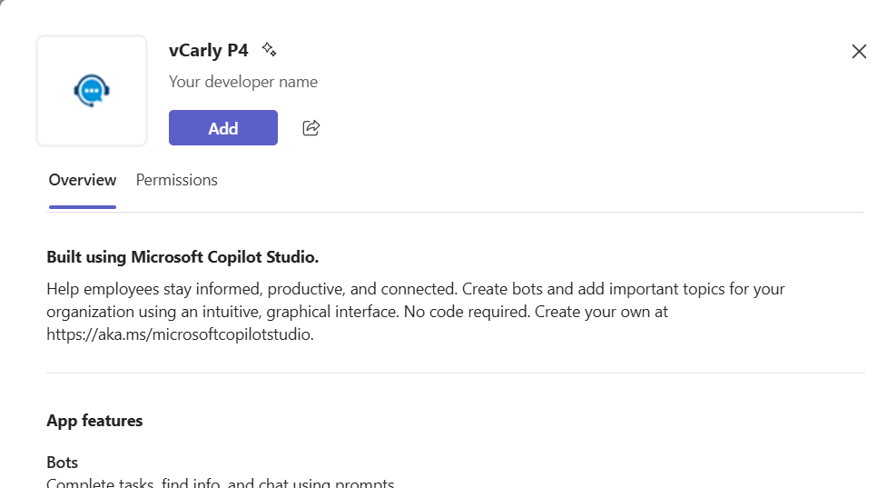

Then the vCarly app will be added in your Teams chat.

To make things easier, remember to pin the app to your side bar.

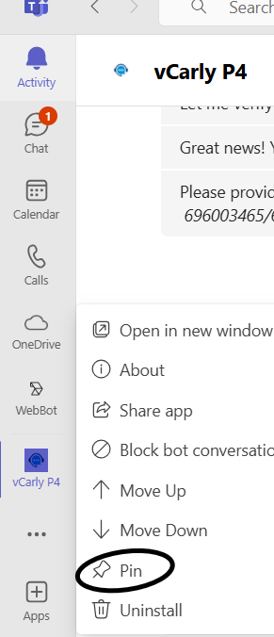

IMPORTANT – ACCESS Request:
Open the chat. If you need access, click yes to request access, then your line manager will receive a notification to approve your request.

How to use the vCarly Application:

To activate the application, you always must write a greeting like “hi” or “hello”
You will get the following message:

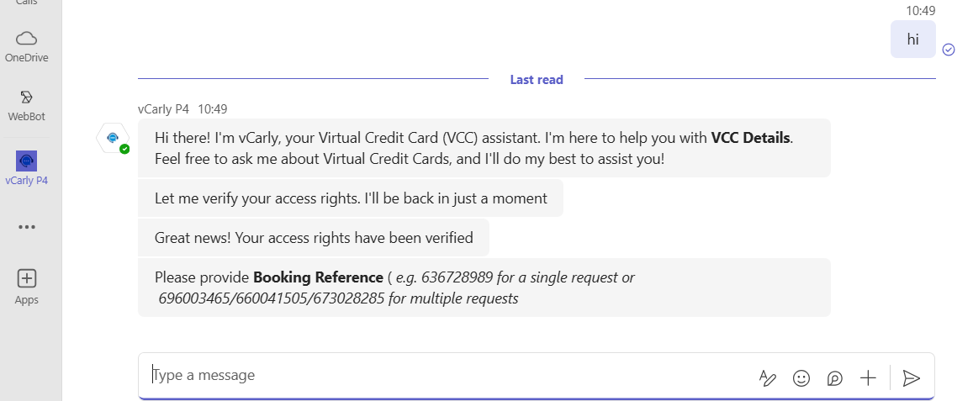

From here we have 3 scenarios, depending on the booking reference entered: invalid booking reference, wrong booking reference or the correct reference number.
In the first stage, vCarly will validate the format of the booking reference. If the booking reference provided is invalid, you will receive an error after you access the link. The below print screen will appear if you introduce the reference in the correct format.

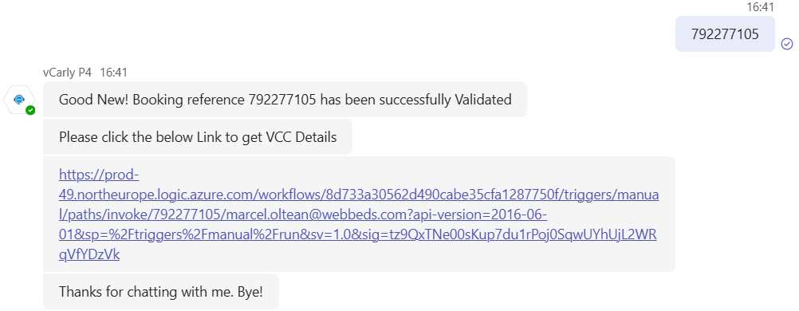

vCarly is working with Dexter. After you click on the link, go back to Teams. you will get a message from Dexter. If your booking reference is invalid, you will receive an error message.
The users will get an error message immediately while chatting if the Booking Reference is not in correct format, as per the print screen below.

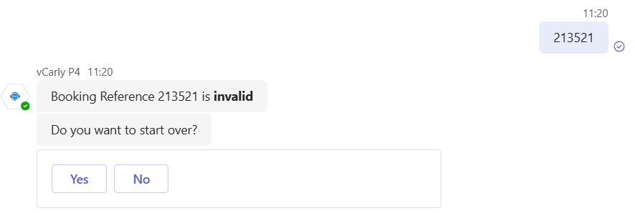

An error message through separate team chat will be displayed if the Booking Refence is invalid.

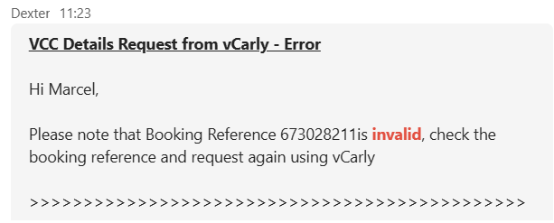

When you provide the correct booking reference Dexter will display VCC Details request, including a secured URL with the VCC Details Link and a Pass Code Link Request. The Pass Code is needed to access the VCC Details.
For DOTW you must provide the booking reference using only the digits and for Maker you need to provide the entire booking reference using the SH letters as well.

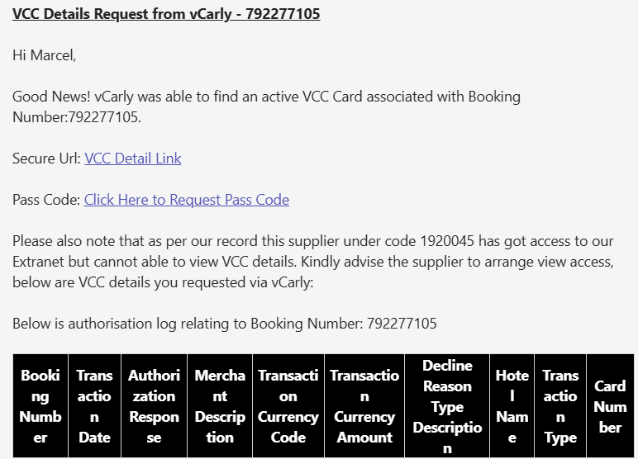

If you typed the wrong booking reference, you need to start from the start. Type “Bye!” to end the communication and type “Hi” or “Hello” to start a fresh new conversation.

Pass Code Request:

Click on the Pass Code link, and a new window will open:
To generate a valid pass code, you need to click on “Edit all” and populate the Freshdesk ID section (Freshdesk Ticket Number).

Scenario 1: The VCC details request is send by email and we have the request in Freshdesk; Use the Freshdesk Ticket number to update the Pass Code Request window.
Ex. If you are responding to a hotel request for VCC, please use the ticket number of the hotels’ request.

Scenario 2: We received the request via phone call, or we need to send the details to a different email address.
Create an outbound email – include the VCC Details link if needed and send it to the hotel. This will create a Freshdesk ticket number that you need to use to update the Pass Code request window.
Make sure you check with the hotel the correct email address at which they would like to receive this information. The pass code will be sent in a separate email, to the email address you sent the outbound email.

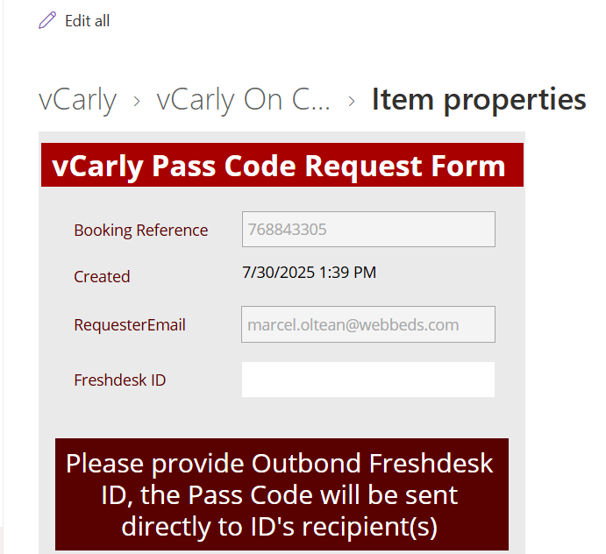

The pass code email has the following format, and it is sent roughly after 60-75 seconds after the request. It is important to remember that the pass code is not sent instantly.

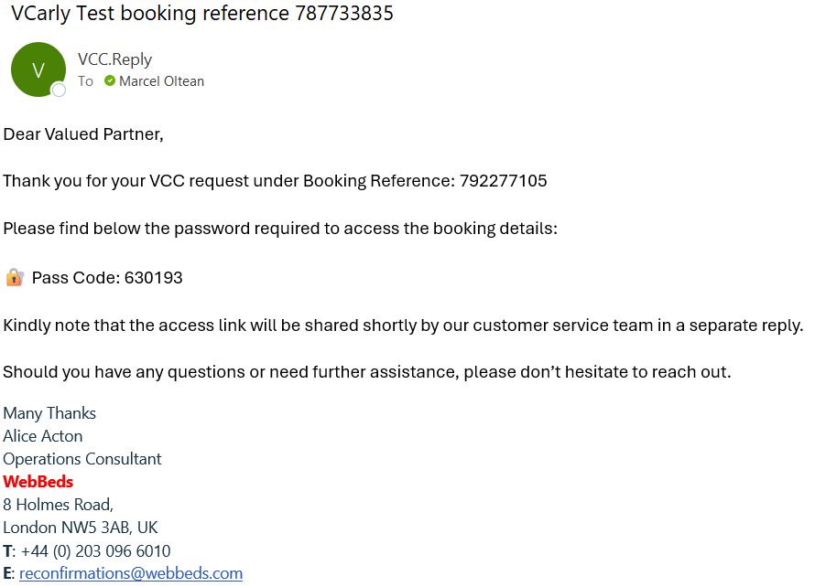

Clicking on the VCC link will open the below window. The hotel needs to use the Pass Code to access the VCC details.

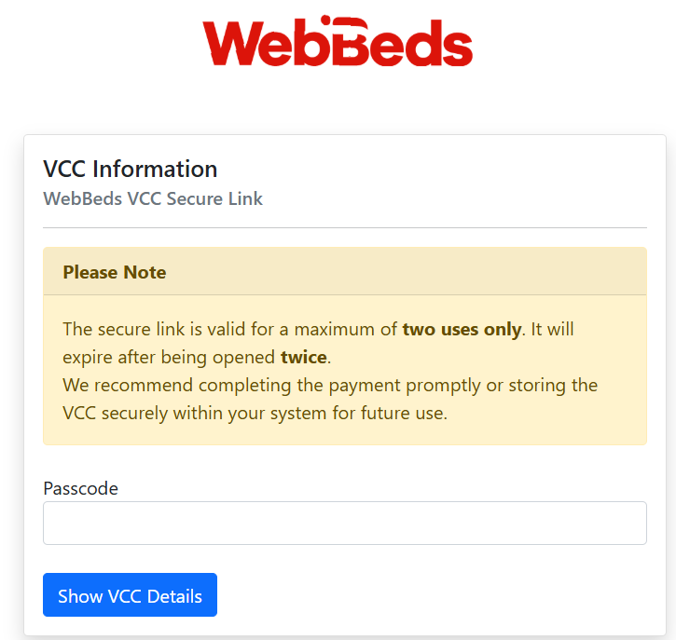
In the Vcarly message bellow the link you will be able to see also the transactions on the VCC.
IMPORTANT: the transactions are working only for WEX VCC’s for the moment (Not working for City and HSBC)

IMPORTANT:

Always check with the hotel if the need the VCC link as well.

When you reply to the hotel, you need to send them the VCC Link only and inform them the Pass Code will arrive in a couple of minutes on a separate email. After sending VCC link to the hotel, you can request the Pass Code to be sent, using Pass Code Link.

